**INSIGHTS ON LIFE SATISFACTION**

**Project Report**

*Submitted in partial fulfilment of the requirements for the award of the degree of*

**Masters**

### *in*

### **Information Technology and Analytics**

*by*

|  |  |
| --- | --- |
| **AJAY VISHNU ADDALA** | (Net id: **aa2569**) |
| **KIREETI MANTRALA** | (Net id: **sm2594**) |



Master’s in information technology and Analytics

Rutgers Business School, Newark

December 2022

**INTRODUCTION**

* Individual utility, or subjective well-being, has been an object of economic studies for a long time. The recent trend is to relate personal well-being, measured as happiness or life satisfaction, to economic factors and explain differences and changes using economic variables.
* We draw different visuals in this presentation to visualise and understand the dependency of multiple factors on Life Satisfaction.
* Annual work hours play a significant role in the overall life satisfaction of a country.
* In our research, we found that the top countries with great life satisfaction are European countries like Finland, Denmark, and Switzerland. We will be comparing the GDP per capita to Life satisfaction and Annual work hours to Life satisfaction for these countries. To broaden our analysis, we have taken one top country from each continent and further visualised them.
* We have Finland (Europe), Israel (Asia), New Zealand (Oceania), Canada (North America), and Uruguay (South Africa).

* The pairs plot gives us the plots between every two sets of variables.
* We can see multiple correlations in the dataset.
* We are more concentrated on the plots of Life Satisfaction with all other variables.
* Hence, we dig deeper into more visuals below.

**Visual 1: BUMP CHART**

* We have taken the bump chart for the Life Satisfaction Ranking for the top four countries.
* As we can see, the top 4 countries belong to the European continent.
* Over the decade, Finland has risen from the top four to the top one, making it the happiest country in the world with the most satisfactory lifestyle.
* On the other hand, Norway saw a dip in the life satisfaction quotient from Europe.
* Israel started at the top four, then dipped way down and ended up in the ninth position.
* Since all the countries are mainly from Europe, we have diversified the analysis.
* We will consider one country with the highest life satisfaction from each continent.

**Visual 2: LINE CHART**

* Six countries have been selected in total, one per each continent
  + Finland – Europe
  + Israel – Asia
  + New Zealand – Oceania
  + Canada – North Americas
  + Uruguay – South Americas
  + South Africa – Africa
* Uruguay and South Africa have fewer life satisfaction numbers than the other countries.
* The remaining four countries have almost the same life satisfaction.

**Visual 3: BUBBLE CHART**

The below Bubble draws the GDP per capita vs Life Satisfaction.

* We can see the countries we considered are towards the highest GDP per capita.
* All six countries are among the countries with one of the highest GDP per capita for the specific continent.

* We can take a closer look at the countries we have selected below. The size of the bubbles depicts the population size.
* We can see that these countries have a lesser population than other densely populated countries.
* Finland, Canada, New Zealand, and Israel lie above the $20,000 mark for GDP per capita and equally lie on the higher (>7.2) average life satisfaction.
* Only Uruguay is on the lower end with around $11,000 GDP per capita and lies at 6.3 on the average life satisfaction scale. But it is the highest compared to all the African countries, and we can see the significant difference in the above visual.

**Visual 4: CONNECTED SCATTER PLOT**

* The annual working hours vs Life Satisfaction visual shows us the increase in annual working hours from 2004-2020.
* We can see that all the other countries’ life satisfaction scale starts above 5.5 and are clustered at one side of the visual, and South Africa has the lowest Life expectancy and the Highest working hours compared to the rest of the world.
* It has increased over the years and decreased a little over the decade's end.
* But South Africa stays and proves that Annual working hours directly impact the Life Satisfaction quotient.
* We dig further into the rest of the continents in the following visual.

* The below visual shows us a closer look at Europe, South America, Canada, New Zealand, and Asia’s Annual working hours vs Life Satisfaction.
* We can see that Europe Stands the highest in life satisfaction. But the least annual working hours are for South America.
* Life satisfaction goes down over the years but ends on a higher note. Similarly for Europe, the working hours are comparatively less, and Life Satisfaction ends on a higher note.
* For Canada and New Zealand, the working hours have increased over the years, but Life Satisfaction has reduced.
* Asia’s working hours are higher than the other three continents. But life satisfaction ends on a higher end for Asia.

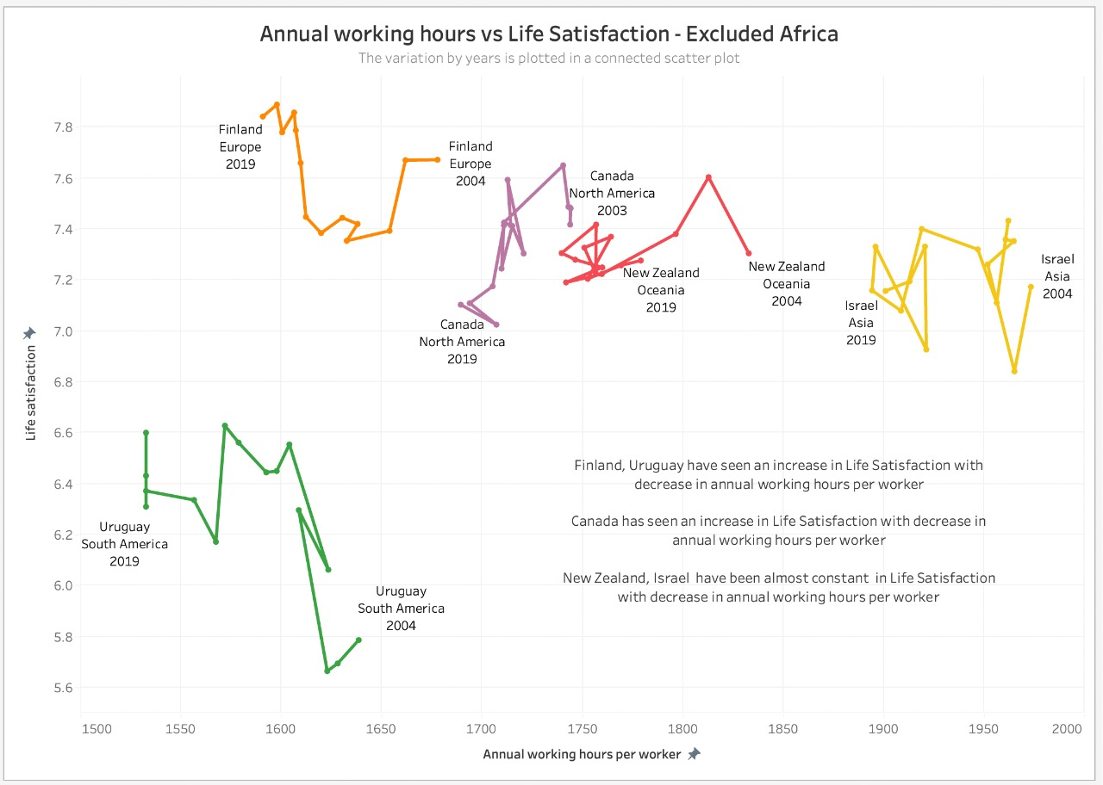

**Visual 5: CONNECTED SCATTER VIDEO**

* The Productivity variation with Life Satisfaction has been plotted in the connected scatter plot video above.
* We can see that variation in Productivity and Life Satisfaction over the years.
* Finland and Uruguay have a positive correlation between Life satisfaction and Productivity.
* Canada and South Africa have a negative correlation between Life satisfaction and productivity.
* New Zealand and Israel show any correlation between Life Satisfaction and Productivity.

**Visual 6: WORLD MAP**

* Urban population % has been plotted in the world map above.
* A differential colour coding has been given to understand the data better.
* All the selected countries with the highest life satisfaction fall in the highest urban population % bucket in their respective continents.
* This specifies a direct correlation between life satisfaction and the urban population % of the countries.

**Visual 7: DUMBELL CHART**

* The Dumbbell Chart has a fascinating insight into Life Satisfaction from 2006-2020.
* We can see that Finland, Israel, and Uruguay’s Average Life Satisfaction quotients have increased over the years.
* But, Larger countries like Canada, New Zealand, and South Africa have lost the Life Satisfaction quotient.

**Visual 8: SLOPE CHART**

* Life Satisfaction plays a very vital role in estimating the Human Development index.
* With higher life satisfaction, we can also see an increase in the human development index.
* The below graphic shows an increase in all the countries’ development indexes over the years.
* Finland has the highest rise from 1990-2021. Finland is known to be the happiest country in the world.

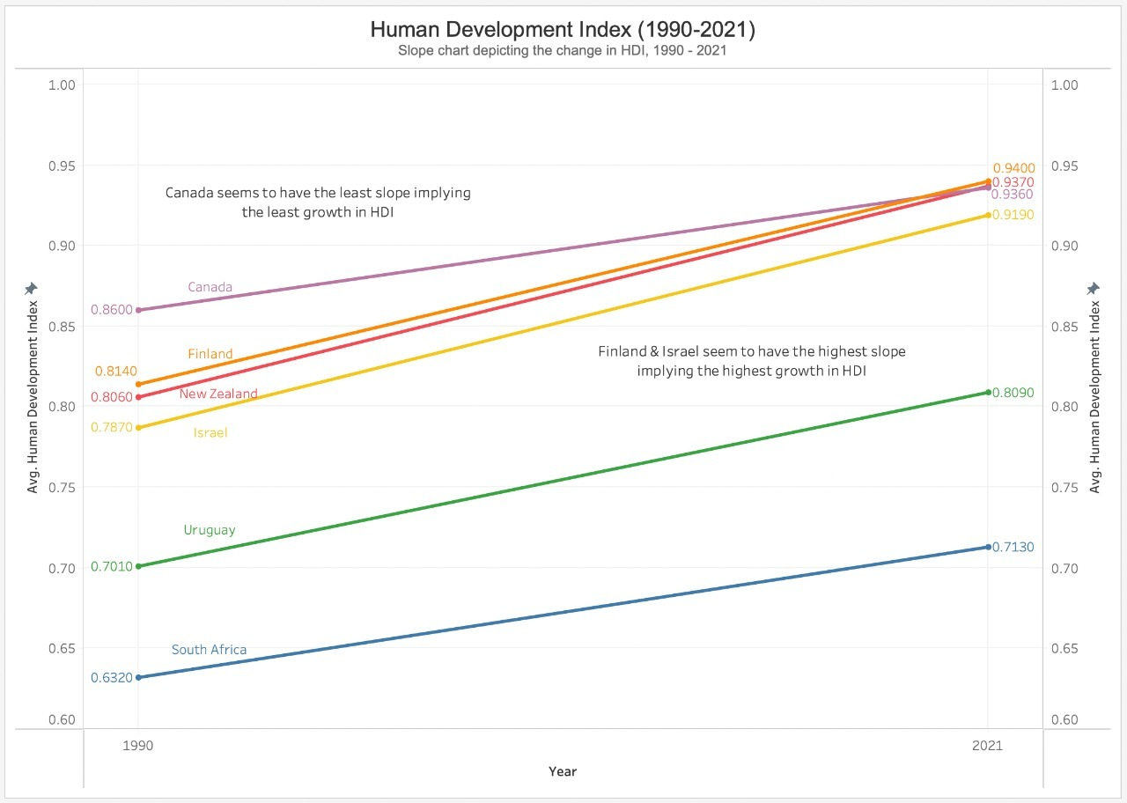

* We can see that the slope of the country Canada is the least, implying that growth in HDI is the least for Canada.
* Finland and Israel have the highest slope, and the slopes of both are almost the same. This indicates that they have the highest growth in HDI.

**Visual 9: BAR CHART**

* We now check the GNI per capita for the selected countries.
* GNI stands for the Gross National Income of the country.
* Gross National Income (GNI) per capita is the dollar value of a country and the final income in a year divided by its population using Atlas methodology.
* Method of estimation: Data from the World Development Indicators database, World Bank.

* Interestingly, we see that Canada has the highest GNI.
* In the previous HDI, we have seen that Canada has the slightest increase in HDI, yet it has the highest GNI per capita.
* Finland, New Zealand, and Israel followed Canada.
* As observed earlier, Uruguay and South Africa took the last two places even in GNI, South Africa being the latest.

**CONCLUSION**

* Initial data was analysed, and the highest life satisfaction-rated country from each continent was considered by analysis.
* South America and Africa have lower life satisfaction scores than the other continents. The rest all have almost similar values.
* The countries with the highest life satisfaction have the highest GDP per capita in their respective continents.
* Not all continents followed the same trend with time when comparing Annual work hours and Life Satisfaction.
* Similarly, not all continents followed the same trend with time when comparing Productivity and Life Satisfaction.
* The countries with the highest life satisfaction fell in the highest urban population % bucket in their respective countries.
* Finland, Israel, and Uruguay have had an increase in life satisfaction. Uruguay had the most significant positive change.
* Canada, New Zealand, and South Africa have had a decrease in life satisfaction.
* Canada had the most remarkable negative change.
* Canada had the least growth in HDI, whereas Finland and Israel had the highest HDI growth.
* Surprisingly, Canada had the highest GNI per capita compared to the rest of the countries. As expected, Uruguay and South Africa were at the bottom of the list.